Submissions

• **Submit two (or one, in a single window) screenshots showing that each web server is up**

**and running its unique page (ex: browsing to http://web01.domain.lan and**

[**http://web02.domain.lan**](http://web02.domain.lan)**)**

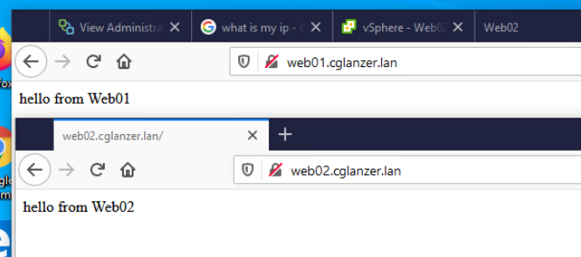

• **Submit a two screenshots showing that you are able to access your web servers by visiting**

**your public IP address. Refresh or use a different browser until you’re able to show both**

**pages.**

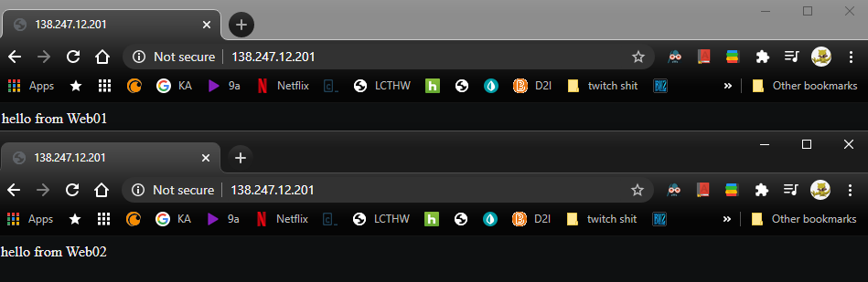

• **Submit a single screenshot of your haproxy config**

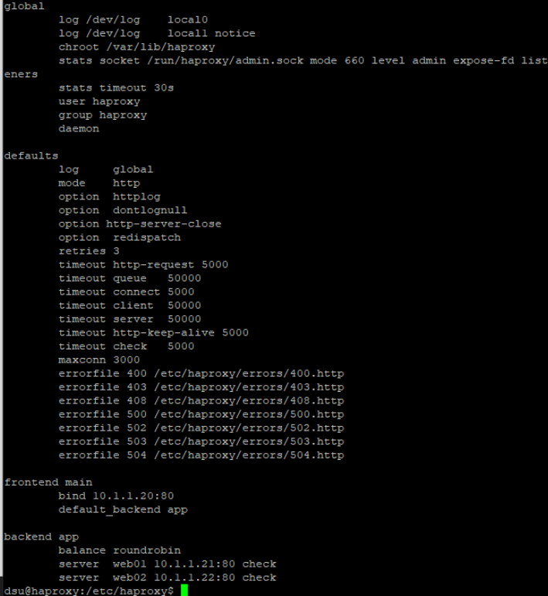

• **Submit a single screenshot showing that your firewall is configured to forward http traffic**

**to your load balancer**

